E-Commerce Sales Analysis Trend
A Project-Based Report Data Science and Visualization (24AD2102) Submitted in partial fulfillment of the requirements for the award of the degree of

BACHELOR OF TECHNOLOGY
In

ARTIFICIAL INTELLIGENCE AND DATA SCIENCE

By
L. Amrutha Reddy (2420080079)
P. Dheeraj (2420080089)
Rohan Joshi (2420080092)

Under the Guidance of
Dr. Venkateswara Rao K
Associate Professor



DEPARTMENT OF ARTIFICIAL INTELLIGENCE AND DATA SCIENCE
KONERU LAKSHMAIAH EDUCATION FOUNDATION
(DEEMED TO BE UNIVERSITY)
BOWRAMPET, HYDERABAD-500043, TELANGANA, INDIA.
OCTOBER - 2025

DECLARATION

The Project-Based Report Data Science and Visualization (24AD2102) entitled “E-Commerce Sales Analysis Trend” is a record of Bonafide work of L.Amrutha Reddy (2420080079), P.Dheeraj (2420080089), Rohan Joshi (2420080092), submitted in partial fulfillment of the requirements for the award of B. Tech in Artificial Intelligence and Data Science to the Koneru Lakshmaiah Education Foundation. The results embodied in this report have not been copied from any other department/University, /Institute.

L. Amrutha Reddy (2420080079)
P. Dheeraj (2420080089)
Rohan Joshi (2420080092)

CERTIFICATE

This is to certify that the project-based report Data Science and Visualization (24AD2102) entitled “E-Commerce Sales Data Analysis” is Bonafide work done and submitted by L. AMRUTHA REDDY (2420080079), P. DHEERAJ (2420080089), ROHAN JOSHI (2420080092) in partial fulfillment of the requirements for the award of the degree of BACHELOR OF TECHNOLOGY in the Department of Artificial Intelligence and Data Science, Koneru Lakshmaiah Education Foundation, during the academic year 2025-2026.

Guide HOD
Dr. Venkateswara Rao K Dr. I. Sreenath
Associate Professor Associate Professor
Dept. of CSE Dept. of AI&DS

ACKNOWLEDGEMENT

With great pleasure, we want to take this opportunity to express our heartfelt gratitude to all the people who helped in making this project a grand success.
We are grateful to Dr. Venkateshwara Rao K, Associate Professor, Department of Computer Science and Engineering, for his valuable technical suggestions and guidance during the execution of this project work.
We want to thank Dr. I. Sreenath, Associate Professor, Head of the Department of Artificial Intelligence and Data Science, Koneru Lakshmaiah Education Foundation, who is the primary driving force behind completing my project work successfully.
We are very grateful to Dr. Venkateshwara Rao K, Coordinator-Academics, Koneru Lakshmaiah Education Foundation, for his constant support and motivation in successfully carrying out the project work.
We are highly indebted to Dr. L. Koteshwara Rao, Principal, Koneru Lakshmaiah Education Foundation, for permitting us to carry out this project in a successful and fruitful way.
We want to thank the Teaching & Non- teaching staff of the Department of Artificial Intelligence and Data Science for their cooperation.
Finally, we thank our parents, who have stood behind us at different project stages. We sincerely acknowledge and thank those who directly and indirectly support completing this project.

L.Amrutha Reddy (2420080079)
P.Dheeraj (2420080089)
Rohan Joshi (2420080092)

CONTENTS

CHAPTER
NO. TITLE PAGE NO.
LIST OF FIGURES ii
LIST OF TABLES iii
ABSTRACT iv
1 INTRODUCTION 1
1.1 Problem Statement 2
1.2 Research Objective 4
1.3 Project Scope and Limitations 5
2 BACKGROUND WORK 7
2.1. Survey-Based AI Impact Analysis 8
2.1.1. Introduction 8
2.1.2. Merits, Demerits and Challenges 9
2.1.3. Implementation of AI Job Impact Modelling 10
2.2. AI Job Impact Modelling 11
2.2.1. Introduction 11
2.2.2. Merits, Demerits and Challenges 12
2.2.3. Implementation of AI Job Impact Modelling 13
2.3. AI Risk Visualization System 15
2.3.1. Introduction 15
2.3.2. Merits, Demerits and Challenges 16
2.3.3. Implementation of AI Risk Visualization System 17

3 PROPOSED SYSTEM 18
3.1. Objective of Proposed Model 20
3.2. Algorithms Used for Proposed Model 21
3.3. Designing Proposed system 24
3.3.1 System Design Overview 25
3.3.2 Workflow of the Proposed System 26
3.4. Stepwise Implementation and Code 28
4 RESULTS AND DISCUSSION 42 4.1. Performance metrics 42
5 CONCLUSION 50
5.1 Conclusion and Future Enhancement 50
REFERENCES 52

GitHub Link 55

List of Figures
FIGURE NO: TITLE PAGE NO.
3.1 Domestic Online Customers (2019 & 2020) 30
3.2 Foreign Online Customers Over the Years
3.3 Product Price
3.4 Overview of E-Commerce Product
3.5 Year-wise E-Commerce Sales Trends
3.7 Month-wise Online Sales Analysis 40
3.8 Region-Year Sales Performance Heatmap

ii

\

List of Tables

FIGURE NO: TITLE PAGE NO.

3.1 Sample Data After Feature Engineering 29
3.2 Online Customers (2019 & 2020) 31
3.3 Foreign Online Customers Over the Years 32

iii

ABSTRACT

This project focuses on E-Commerce Sales Analysis Trend in India, aiming to study the growth, trends, and patterns of e-commerce in the state using real-world data E-commerce is transforming retail through convenience, variety, and data-driven personalization. This project analyzes historical sales data to uncover trends, seasonal patterns, and performance metrics across product categories and regions. The goal is to generate actionable insights that support inventory optimization, marketing strategies, and customer satisfaction.

E-commerce companies collect a lot of sales data, but they often don’t use it effectively to understand what’s selling well, when, and where. Without this analysis, it’s hard to plan inventory, target customers, or improve sales strategies. E-commerce sales analysis involves examining the data generated from online transactions to gain insights into customer behavior, product performance, and market trends. Every time a customer browses or purchases a product online, data is collected, such as the type of product bought, purchase time, payment method, location, and device used. By studying this data, businesses can identify which products are in high demand, which marketing campaigns are effective, and which customer groups buy more frequently. It also helps to detect seasonal patterns—such as an increase in sales during festivals, holidays, or discount periods—allowing companies to plan their sales strategies more efficiently.

This analysis is crucial because it helps businesses make informed decisions that can improve both customer experience and profitability. E-commerce sales analysis is a powerful tool that supports business growth and competitiveness in the digital marketplace. It helps companies understand their customers better, optimize product offerings, enhance marketing strategies, and manage resources effectively. By using data-driven insights, businesses can improve customer satisfaction, reduce costs, and increase overall sales performance.
iv

CHAPTER 1
INTRODUCTION

1
CHAPTER 1
INTRODUCTION
  - Problem Statement
India is a rapidly growing digital economy with millions of online shoppers, yet the e-commerce sector often lacks a systematic, data-driven approach to understanding customer behaviour and product performance. Information related to sales volumes, customer demographics, seasonal buying patterns, and promotional impacts is frequently scattered across multiple platforms and not analysed effectively. This makes it difficult for companies and online marketplaces to make informed decisions based on real customer needs and market conditions.
Without proper sales analysis, it becomes challenging to identify peak shopping periods, understand which products perform best, or evaluate the success of marketing campaigns and discount strategies. The lack of organized data visualization and actionable insights limits the ability of e-commerce businesses to optimize pricing, enhance inventory management, and improve customer service. As a result, companies may face issues such as stock shortages, excess inventory, missed sales opportunities, or ineffective promotional spending.
Data sources are often inconsistent or incomplete, especially when small retailers, new sellers, or rural businesses enter online marketplaces. The format of sales records is not always standardized, leading to difficulties in integrating data across multiple platforms such as Amazon, Flipkart, Meesho, and independent seller websites. Additionally, festival seasons, flash sales, and cultural shopping trends cause sudden fluctuations in sales volumes, making it harder to model future demand. Technical challenges also arise in handling missing data, duplicate entries, returns/refunds, and distinguishing genuine trends from temporary spikes in sales.

2
Challenges Faced in the Study
- Data Availability and Accuracy: Collecting reliable and up-to-date e-commerce sales data was difficult because data from sellers, platforms, and marketplaces was often incomplete, or outdated. Some vendors did not maintain proper digital records, which created gaps in the dataset.
- Data Integration: Sales data originated from multiple online platforms such as Amazon, Flipkart, Meesho, and individual seller websites. Integrating this data into a single system required extensive cleaning, formatting, and standardization to remove duplicates and unify measurement units.
- Limited Digital Records for Small Sellers: Many small-scale sellers and local businesses transitioning to online platforms lacked structured digital transaction records. This limited the representation and completeness of sales insights across different product categories and regions.
- Seasonal and Festival-Based Fluctuations: E-commerce sales volume varies heavily during festive seasons, discount periods, and promotional campaigns. These sudden spikes and drops made it challenging to identify stable trends or forecast future sales accurately.
- Handling Missing Data and Outliers: The dataset contained missing values, extreme price variations, and unusual spikes in order quantity due to limited-time offers or bulk purchases. Accurate analysis required careful preprocessing to handle outliers and fill missing data without distorting results.
- Technical and Analytical Limitations: Conducting advanced data analytics, trend forecasting, and data visualization required the appropriate use of specialized tools, coding skills, and statistical models. Ensuring accuracy and reliability of insights took additional time and technical knowledge.
3

  - Research Objective
The primary objective of this study is to analyse e-commerce sales data in India to gain a deeper understanding of customer behaviour, product demand, and the performance of various sales strategies. By examining purchasing patterns, seasonal sales fluctuations, and consumer preferences, the study aims to generate actionable insights that can guide e-commerce companies, retailers, and policymakers in improving their marketing approaches, inventory planning, and promotional strategies. This will help businesses enhance customer satisfaction and increase sales efficiency across different regions and product categories.
E-commerce plays a crucial role in driving economic growth, creating employment opportunities, and promoting digital transformation in India. This study addresses these challenges by systematically collecting, organizing, and analysing sales data from multiple platforms to provide a comprehensive view of market trends and consumer behaviour. The analysis is intended to help stakeholders adopt data-driven strategies for sustaining growth and improving operational performance.
- Data Collection and Organization: To gather accurate and relevant e-commerce sales data from marketplaces, retailer databases, and online platforms, ensuring proper structuring and cleaning for analysis.
- Trend Analysis: To identify patterns in customer purchases, monthly and seasonal sales variations, and peak demand periods, helping businesses understand how consumer behaviour changes over time.
- Product and Sales Performance Evaluation:To assess the popularity, profitability, and demand level of different product categories, discount strategies, and promotional campaigns.
- Data Visualization: To present insights using graphs, charts, and dashboards, allowing decision-makers to interpret data clearly and make informed business choices.
- Predictive Insights: To apply statistical and analytical techniques to forecast future sales trends, customer demand, and inventory requirements to support proactive business planning.
4
1.3. Project Scope and Limitations
The scope of this project outlines the focus, limits, and expected outcomes of the study on E-Commerce Sales Analysis. The project aims to provide a comprehensive understanding of customer purchasing patterns, product demand, seasonal sales behavior, and the performance of various sales strategies. The major components included in the scope are:
- Data Collection: Gathering authentic sales data from e-commerce platforms, vendor records, and online marketplaces, including product categories, sales volume, customer demographics, and seasonal sales trends.
- Data Organization: Cleaning, sorting, and structuring the collected data to ensure accuracy and consistency. This involves removing duplicates, handling missing values, and standardizing data formats.
- Data Analysis: Identifying sales trends, purchasing patterns, price sensitivities, and product demand across different regions and time periods using statistical, comparative, and analytical techniques.
- Data Visualization: Presenting the analytical findings through charts, graphs, dashboards, tables to make the results easier to understand and use for decision-making.
- Sales Strategy Performance Evaluation: Assessing the effectiveness of discount campaigns, promotional offers, product bundling, advertising methods, and category-specific sales strategies.
- Predictive Insights: Using forecasting methods to estimate future sales trends, customer demand peaks, and inventory requirements to support proactive planning and reduce operational inefficiencies.
- Decision Support: Providing actionable recommendations to e-commerce companies, sellers, and marketing teams to improve sales planning, enhance customer experiences, optimize supply chains, and support sustainable business growth.
The project focuses on the Indian e-commerce market, covering both urban and developing digital regions, with the goal of improving sales performance, strengthening customer engagement, and enhancing competitiveness in the fast-growing digital commerce ecosystem. 5
Limitations
Despite its scope, the project faces certain limitations that may influence the accuracy and depth of the e-commerce sales analysis:
- Data Availability: Complete, real-time sales data is not always accessible, especially for small-scale sellers or newly established online businesses. Some platforms restrict detailed data sharing, which can limit the comprehensiveness of analysis.
- Data Quality: Sales data collected from different e-commerce platforms and vendors may be inconsistent, incomplete, or presented in different formats. This variation can affect the level of accuracy and may require extensive preprocessing.
- Time Constraints: The study focuses on a specific time period and may not fully capture long-term changes, rare market fluctuations, or evolving customer purchasing trends over several years.
- Predictive Constraints: Forecasting future sales trends depends heavily on available historical data. Limited or noisy data can reduce the reliability of predictions and analytical modelling outcomes.
- Geographical Focus: This study is limited to the Indian e-commerce market. Therefore, the findings and insights may not be directly applicable to other countries or international markets with different consumer behaviours and market conditions.
- External Influences: Factors such as economic shifts, policy changes, technological disruptions, global supply chain issues, natural disasters, or pandemics can significantly impact e-commerce sales patterns—and these influences may not be fully accounted for within the scope of the analysis.

6

CHAPTER 2
BACKGROUND WORK

7

CHAPTER 2
BACKGROUND WORK

2.1. Survey-Based AI Impact Analysis

2.1.1 Introduction

E-commerce has become one of the most dynamic and rapidly growing sectors, transforming the way businesses operate, interact with customers, and deliver products and services. With the rise of digital platforms, online marketplaces, and mobile shopping, consumer purchasing behaviour has shifted significantly. However, despite this growth, the actual performance, customer satisfaction levels, and effectiveness of sales strategies often remain difficult to evaluate without a structured analytical approach. This is where e-commerce sales analysis becomes essential.
E-commerce sales analysis involves examining transactional data, shopping patterns, customer preferences, and product performance to understand how well an online business is functioning. Unlike general financial reviews, this analysis focuses on both quantitative metrics such as sales volume, conversion rate, revenue growth, and customer retention and qualitative insights such as consumer satisfaction, perceived value, and shopping experience feedback. By combining these perspectives, businesses can gain a complete understanding of what drives sales, what challenges customers face, and which strategies generate the best results.
In the e-commerce sector, data-driven decision-making has become crucial for improving product recommendations, personalized marketing, stock management, and pricing strategies. Sales analysis helps identify best-selling products, customer buying cycles, seasonal demand shifts, and the impact of promotional campaigns. Through structured evaluation and continuous monitoring, e-commerce organizations can optimize their operations, enhance user satisfaction, and maintain sustainable growth in a highly competitive digital marketplace.
8

By applying survey-based analysis, stakeholders can evaluate how customers perceive these AI-driven features, identify challenges in user adoption, measure satisfaction levels, and determine the effectiveness of these tools in improving sales. This assessment helps companies understand whether AI solutions are meeting customer expectations and highlights areas where platform design, interaction quality, or personalization strategies can be improved for better sales outcomes.

2.1.2 Merits, Demerits, and Challenges
- Merits:
- Provides Direct Consumer Insights: Helps understand customer preferences, satisfaction levels, and purchasing behaviour directly from real sales data.
- Combines Quantitative and Qualitative Information: Sales figures (quantitative) along with customer reviews and feedback (qualitative) provide a complete understanding of market performance.
- Identifies Market and Buying Trends: Helps detect seasonal demand patterns, fast-moving products, and emerging customer interests to support strategic planning.
- Supports Data-Driven Decision Making: Enables businesses to base pricing, inventory management, and marketing strategies on factual data rather than assumptions.
- Cost-Effective and Scalable: Can be applied across small sellers to large e-commerce platforms with flexible tools and minimal additional resources.
- Demerits:
- Biased Data: Customer reviews or sales trends may not always show the real situation.
- Limited Data: Small or incomplete data cannot represent the entire market accurately.
- Data Errors: Poorly organized or missing data can lead to wrong conclusions.
- More Time & Resources Needed: Proper data analysis requires skilled people, tools, and time.
- Difference in Words vs. Actions: What customers say in surveys may not match what they actually buy.
9
- Challenges:
- It is difficult to ensure that all users give honest and accurate responses.
- Combining numerical data with written opinions can be challenging.
- AI technology changes quickly, making it hard to keep systems updated.
- Getting enough participants to complete surveys is often difficult.
- Differences in culture, age, and background can affect how AI is perceived.
- Privacy and data security must be carefully managed to protect users’ information.

2.1.3 Implementation of Survey-Based Methods
The implementation of survey-based methods in e-commerce sales analysis is a systematic approach used to evaluate the performance and impact of digital sales strategies by collecting direct feedback from customers, sellers, and business stakeholders. In the context of e-commerce, these methods help assess how technologies such as chatbots, personalized product recommendations, automated checkout systems, and digital marketing campaigns influence buying behavior, customer satisfaction, and overall sales growth.
The process begins by defining clear objectives for the survey, such as understanding customer purchase preferences, identifying pain points in the shopping process, or evaluating the effectiveness of online customer support. After determining these goals, a structured survey is designed using a mix of closed-ended questions (to gather measurable sales and satisfaction data) and open-ended questions (to capture customer opinions, experiences, and suggestions in detail).
Next, the target respondents—such as frequent online shoppers, occasional users, e-commerce sellers, and support teams—are identified to ensure diverse insights. Surveys
10
may be distributed through email forms, website pop-ups, mobile apps, social media platforms, and post-purchase feedback
requests. The collected data is then analyzed to identify patterns in buying trends, product demand, and service satisfaction. These insights help businesses improve website design, pricing strategies, product recommendations, marketing approaches, and customer support systems, ultimately supporting data-driven decisions to enhance e-commerce sales performance.
Once survey responses are collected, the data is cleaned and processed to remove incomplete entries, duplicates, and inconsistencies. The cleaned data is then analyzed using statistical methods and visualization tools—such as graphs, charts, and dashboards—to identify trends in customer buying behaviour, product popularity, sales performance, and satisfaction levels with e-commerce services.
The results are summarized to highlight strengths and weaknesses in e-commerce operations, such as website usability, product recommendations, and customer support efficiency. Based on these findings, actionable recommendations can be made—for example, improving recommendation algorithms, enhancing chatbot accuracy, optimizing checkout processes, or providing multilingual support for diverse customer groups.
Through this structured approach, survey-based analysis provides reliable, data-driven insights that help e-commerce companies make informed decisions, improve service delivery, enhance customer satisfaction, and support sustainable growth in the Indian online marketplace.
2.2. AI Job Impact Modeling
2.2.1 Introduction
11
Artificial Intelligence (AI) is transforming industries globally by automating routine tasks, enhancing decision-making, and improving operational efficiency. While AI opens new opportunities for innovation, it also raises concerns about job displacement, skill gaps, and workforce adaptation. AI Job Impact Modeling is a systematic approach used to study
how AI technologies influence employment patterns, job creation, and skill requirements across various sectors.
This modeling process helps identify the balance between automation and human labor, highlighting which roles are likely to be replaced, transformed, or newly created. In the e-commerce sector, AI tools such as chatbots, recommendation engines, automated checkout systems, and personalized marketing solutions are reshaping traditional job functions.
Routine administrative and customer support tasks are increasingly being handled by AI, while new roles are emerging in data analytics, AI system management, digital marketing, and customer experience optimization. AI Job Impact Modeling leverages employment data, automation trends, and skill requirements to predict workforce changes and guide strategies for reskilling employees. This allows e-commerce companies and policymakers to determine which roles require human expertise—such as personalized customer service or strategic decision-making—and which can be optimized through automation.
In India’s e-commerce industry, AI Job Impact Modeling provides insights into how technology adoption affects employment patterns, workforce composition, and skill development needs. By anticipating workforce shifts, businesses can train employees for future roles, ensuring that technological advancement is accompanied by human skill growth. Overall, this modeling approach supports sustainable e-commerce growth, minimizes unemployment risks, and promotes a future-ready workforce that adapts responsibly to technological change while fostering inclusive development in the digital economy. In India’s e-commerce sector, such analysis can determine how AI adoption influences employment patterns, workforce composition, and skill development requirements. By anticipating workforce changes, businesses can train employees for future roles, ensuring that technological advancement is accompanied by human skill growth

12

2.2.2 Merits, Demerits, and Challenges

Merits:
  - Predictive Insight: Helps forecast future workforce trends and identify which roles in e-commerce are most influenced by AI automation.
  - Strategic Planning: Assists companies and policymakers in developing reskilling programs and sustainable job creation strategies.
  - Data-Driven Decision Making: Provides evidence-based insights into how AI affects various job functions in the e-commerce sector.
  - Balanced Technological Growth: Supports integrating AI while maintaining essential human expertise for customer service, strategy, and operations.
  - Skill Gap Identification: Highlights emerging skills and helps design training programs to prepare employees for new AI-driven roles.

Demerits:
  - Data Limitations: Reliable and up-to-date employment data related to AI adoption is often difficult to obtain.
  - Uncertain Predictions: Rapid technological changes can make long-term workforce forecasts less accurate.
  - Bias in Modelling: Models may unintentionally reflect existing economic or social inequalities.
  - Complex Interpretation: Understanding and applying model outcomes can be challenging for small businesses and policymakers.
  - Cost and Expertise Requirements: Developing accurate models requires skilled analysts and advanced computational tools.
Challenges:
- Dynamic Workforce Changes: Constant evolution of AI tools makes it hard to keep models current.
13
  - Sectoral Differences: AI impacts different industries differently; in e-commerce, roles in customer service, logistics, and marketing are affected more than others.
  - Ethical Concerns: Job displacement and inequality issues raise moral and social challenges.
  - Skill Mismatch: Many employees may lack the technical knowledge required for AI-related roles.
  - Implementation Gap: Translating model insights into actionable workforce policies is often difficult due to administrative and resource constraints.

2.2.3 Implementation of Employment Statistics Methods
The implementation of sales analytics methods is essential to analyse and interpret how e-commerce technologies, including AI-driven tools, affect business performance, customer behaviour, and market trends. These methods help in collecting, processing, and visualizing sales data to understand both the opportunities and challenges in the e-commerce sector, such as product demand, peak sales periods, and the effectiveness of marketing or promotional strategies.
The process begins with data collection from authentic sources such as e-commerce platform records, sales databases, customer surveys, and company reports. This data typically includes information about product categories, sales volumes, customer demographics, seasonal demand, and marketing campaign performance. For example, in e-commerce, it may involve data on how AI tools like chatbots, recommendation systems, and automated checkout processes influence sales efficiency and customer service operations.
Next, the data undergoes classification and preprocessing to organize products, customer segments, and sales patterns. This may involve grouping products by demand levels, categorizing customers based on purchase behaviour, or identifying high-performing and low-performing sales periods. After cleaning and structuring the data, statistical techniques such as regression analysis, trend analysis, and correlation studies are applied to uncover meaningful patterns, predict future sales trends, and optimize operational strategies.
14
Correlation studies and time-series forecasting are applied to identify trends and relationships between e-commerce technology adoption—such as AI-driven tools, automated systems, and recommendation engines—and business performance indicators like sales growth, customer engagement, and operational efficiency.
The analysis phase focuses on visualizing sales and customer patterns using graphs, charts, and dashboards to make insights clear and actionable. These visualizations help identify high-performing products, peak sales periods, customer preferences, and areas where marketing or operational improvements are needed.
Finally, the outcomes are interpreted and reported to guide e-commerce businesses, platform managers, and policymakers. This supports effective decision-making for inventory planning, targeted promotions, customer experience optimization, and long-term growth strategies.
In India’s e-commerce context, implementing these analytical methods can reveal how AI integration and digital tools influence sales performance, operational efficiency, and market competitiveness. Through continuous monitoring and analysis, sales analytics methods ensure a data-driven approach that balances technological adoption with business stability and sustainable growth.
2.3. AI Risk Visualization System

2.3.1 Introduction

As Artificial Intelligence (AI) becomes more integrated into various sectors, it brings not only opportunities for automation and efficiency but also potential risks that can impact data security, fairness, and reliability. The AI Risk Visualization System is designed to identify, analyse, and visually represent these risks to support better understanding and management of AI-related challenges.
15
AI systems can face issues such as data bias, privacy violations, algorithmic errors, and ethical dilemmas. The complexity of these systems often makes it difficult for decision-makers to detect and address risks promptly. The AI Risk Visualization System simplifies this process by converting complex analytical data into visual formats such as graphs, heat maps, dashboards, and network diagrams. These visuals make it easier to interpret patterns, detect anomalies, and evaluate potential risk levels across AI applications.
In the context of India’s e-commerce data analysis, this system can help monitor AI-based tools used for visitor prediction, feedback analysis, and automated service recommendations. By identifying risks like inaccurate predictions, data misuse, or system vulnerabilities, e-commerce authorities can ensure that AI technologies operate transparently and securely.
Moreover, AI Risk Visualization fosters trust, accountability, and informed decision-making among stakeholders. It helps organizations mitigate threats before they escalate, ensuring safe and responsible AI adoption.
Overall, the AI Risk Visualization System serves as an essential framework for promoting ethical, transparent, and risk-aware AI deployment, enabling both technological progress and public confidence in AI-driven solutions.
2.3.2 Merits, Demerits, and Challenges
Merits:
- Improved Understanding: Converts complex AI risk data into clear visual representations, making it easier for stakeholders to interpret.
- Early Risk Detection: Enables quick identification of potential problems such as bias, data breaches, or algorithmic errors.
- Enhanced Decision-Making: Supports policymakers and developers in implementing effective mitigation strategies based on real-time insights.
- Transparency and Accountability: Promotes trust by clearly showing how AI systems perform and where risks lie.
- Cross-Sector Application: Can be applied in multiple fields like e-commerce, healthcare, and finance to ensure responsible AI use.
16
Demerits:

- Data Dependence: Accuracy relies heavily on the quality and completeness of input data.
- High Implementation Cost: Requires advanced tools, software, and technical expertise to develop and maintain.
- Complex Setup: Integration with existing systems can be challenging, especially in traditional industries.
- Overreliance on Visualization: Users may focus on visuals without understanding underlying data or algorithms.
- Limited Scope: May not capture all types of risks, especially those related to ethical or long-term societal impacts.
Challenges:
- Data Privacy and Security: Ensuring sensitive data used in visualization is protected against misuse or breaches.
- Model Bias Identification: Detecting and correcting biases within AI models remains a complex task.
- Scalability Issues: Adapting the system for large datasets or multiple AI models can be resource-intensive.
- Technical Expertise: Requires skilled personnel to design, interpret, and maintain visualization tools.
- Continuous Monitoring: AI systems evolve rapidly, making it necessary to update risk models and dashboards regularly.

17
2.3.3 Implementation of AI Risk Visualization Methods
The implementation of AI Risk Visualization Methods involves designing systems that collect, process, and display data related to potential risks in AI operations. The goal is to help stakeholders identify vulnerabilities, understand model behaviour, and ensure ethical and secure use of AI technologies.
1. Data Collection and Preparation:
Risk-related data such as algorithm performance metrics, error rates, bias indicators, and data privacy logs are gathered from multiple sources. This data is cleaned, normalized, and categorized to ensure consistency and reliability before visualization.
2. Risk Modelling:
Machine learning models are used to identify and predict potential risks like bias, overfitting, or system instability. These models analyse historical data and detect anomalies or patterns that could indicate future threats.
3. Visualization Techniques:
Interactive dashboards, heat maps, and risk matrices are created using visualization libraries like Plotly, Tableau, or Power BI. These tools help users view real-time updates on AI model health, data fairness, and system reliability.
4. Integration with AI Systems:
The visualization platform is connected to live AI systems or databases. This enables continuous monitoring and automatic updates of risk levels as new data is processed.
5. Decision Support and Reporting:
Visual insights are used by AI developers, managers, and policymakers
18
to make informed decisions regarding system improvement, retraining needs, or compliance actions. Automated reports summarize detected risks and suggest mitigation measures.
6. Evaluation and Feedback:
Regular evaluation ensures the system remains accurate and adaptable. User feedback is incorporated to refine visual designs, improve usability, and enhance interpretability of risk indicators.

19

CHAPTER 3
PROPOSED SYSTEM

20
21

CHAPTER 3
PROPOSED SYSTEM

3.1 Objective of the Proposed Model
The proposed model aims to develop an intelligent, data-driven analytical system that leverages Artificial Intelligence (AI) and visualization techniques to analyse, interpret, and forecast patterns within e-commerce or employment datasets. This model focuses on transforming raw data into meaningful insights that can enhance strategic planning, policy formulation, and operational efficiency.
The primary goal is to create a robust analytical framework that not only processes data but also identifies risks, trends, and opportunities through AI-based modelling and visualization. By integrating predictive algorithms with interactive dashboards, the model supports decision-makers in understanding complex data relationships in a clear and actionable manner.
Key Objectives:
- Comprehensive Data Collection and Integration:
To gather relevant datasets from authentic sources such as government e-commerce boards, employment records, and digital survey systems, ensuring accuracy and consistency in data representation.
- Data Preprocessing and Management:
To clean, normalize, and structure the collected data for efficient use in AI modelling and visualization tasks, eliminating redundancies and inconsistencies.
22
- Predictive and Trend Analysis:
To employ AI and machine learning algorithms that can detect patterns, predict future trends, and forecast key indicators such as visitor inflow, employment shifts, or regional performance variations.
- Visualization and Interpretation:
To design interactive dashboards that present complex sales and operational data in a simplified way using charts, heatmaps, and graphs, enabling stakeholders to quickly understand trends and make informed business decisions.
- Risk Detection and Monitoring:
To integrate a risk visualization component that identifies potential anomalies, system errors, or data inconsistencies in e-commerce platforms, allowing proactive measures to prevent operational or customer-related issues.
- Decision-Making and Policy Support:
To assist e-commerce companies, platform managers, and industry authorities in making data-backed decisions for optimizing inventory, marketing strategies, and resource allocation.
- Sustainability and Scalability:
To build a model that can adapt to changing sales datasets, scale across different product categories and platforms, and remain effective for long-term use through continuous updates and improvements.
- Performance Evaluation and Optimization:
To regularly assess the model’s accuracy, efficiency, and reliability, refining algorithms based on new sales trends, customer behaviour patterns, and operational feedback to improve overall e-commerce performance.

3.2 Algorithms Used for the Proposed Model
The proposed model integrates a combination of Artificial Intelligence (AI), Machine Learning (ML), and Data Visualization algorithms to analyse and interpret large datasets efficiently. These algorithms help in identifying trends, predicting future outcomes, and visualizing data patterns that support better decision-making.
23
The following algorithms are used in the proposed model:
- Data Preprocessing Algorithms
Before applying AI models, raw data is pre-processed to remove inconsistencies, handle missing values, and standardize formats.
- Normalization: Used to scale numerical data within a uniform range to improve model accuracy.
- Missing Value Imputation: Techniques like mean, median, or mode replacement are used to handle incomplete data.
- Data Encoding: Converts categorical data into numerical form using label or one-hot encoding for ML compatibility.

- Clustering Algorithm – K-Means
- Purpose: To group sales data into clusters based on similarities, such as customer purchase behaviour, product preferences, regional sales patterns, or seasonal trends.
- Working: The algorithm assigns each data point (e.g., a customer or product) to the nearest cluster centroid and iteratively adjusts the centroids until the clusters stabilize, ensuring that similar data points are grouped together.
- Use Case: Helps identify groups of customers with similar buying patterns, products that perform similarly, or regions with comparable sales trends, allowing businesses to target marketing campaigns, optimize inventory, and improve personalized recommendations.

- Classification Algorithm – Decision Tree
• Purpose:
To classify sales or customer data into categories and predict outcomes such as product success, customer satisfaction levels, or the effectiveness of marketing strategies.
24
• Working:
The model splits data based on attribute values into branches, forming a tree structure where each node represents a decision rule. This allows the algorithm to classify data and make predictions systematically.
• Use Case:
Helps predict whether products or promotions will perform well, whether customers are likely to be satisfied, or which sales strategies are most effective. It enables e-commerce businesses to make data-driven decisions for improving sales and customer experience.

- Regression Algorithm – Linear Regression
- Purpose: To analyze and predict numerical trends such as future sales volume, revenue growth, customer purchase frequency, or seasonal demand fluctuations.
- Working: The algorithm establishes a linear relationship between a dependent variable (e.g., sales) and one or more independent variables (e.g., price, advertisement cost, festival season, customer ratings). It then generates a best-fit line to represent the trend and make future predictions.
- Use Case: Helps predict future sales trends based on historical data patterns. For example, it can forecast how many units of a product will sell next month or how changes in price or promotions may affect total revenue.
- Sentiment Analysis Algorithm – Natural Language Processing (NLP)
• Purpose: To analyze customer feedback, product reviews, or user comments to understand public opinion regarding e-commerce services, product quality, delivery experience, and overall customer satisfaction.

25
• Working: Uses text-mining, tokenization, and natural language processing (NLP) techniques to categorize text data into positive, negative, or neutral sentiments. The system identifies keywords, tone, and context to determine the emotional opinion expressed in the review.
• Use Case: Helps evaluate customer satisfaction levels and understand consumer preferences, complaints, and expectations. This allows e-commerce companies to improve customer service, product offerings, and marketing strategies.
- Visualization Algorithms – Matplotlib and Plotly
- Purpose: To visually represent analyzed data using dynamic and interactive charts.
- Working: Converts processed datasets into bar charts, pie charts, heatmaps, and trend graphs for easier interpretation.
- Use Case: Displays e-commerce trends, AI impact distribution, or regional performance comparisons.
- Risk Analysis Algorithm – Anomaly Detection
- Purpose: To identify irregularities or unexpected patterns in data that may indicate risks or errors.
- Working: Uses statistical thresholds or machine learning methods to flag data points that deviate significantly from normal behaviour.
- Use Case: Detects unusual visitor activity, system anomalies, or errors in employment prediction results.

The integration of these algorithms allows the proposed model to conduct a complete analysis process, including data preparation, prediction, clustering, sentiment evaluation, and visual representation. This multi-layered approach enhances accuracy, efficiency, and reliability, making the model well-suited for analyzing both e-commerce trends and employment data and applications.
26
3.3 Designing of the Proposed System
The proposed system is designed to conduct a detailed analysis and visualization of e-commerce data in India, offering meaningful insights into visitor behavior, product/package preferences, and seasonal sales trends. By applying Artificial Intelligence (AI) techniques along with data preprocessing and visualization methods, the system converts raw data into useful and actionable information.
This design ensures a smooth and organized workflow at every stage—starting from data collection and cleaning to processing and final visualization. The result is a reliable, accurate, and easy-to-interpret output that supports the India E-Commerce Department in making informed, data-driven decisions for improved planning and performance.
3.3.1 System Design Overview
The proposed system follows a modular and layered design to ensure scalability, clarity, and maintainability. Each module has a specific function that contributes to the overall data analysis and visualization process.
The major components of the system are as follows:
- Data Input Layer:
• Collects raw e-commerce data from reliable sources such as the India E-Commerce Portal, company databases, and transaction records.
• Includes details like customer visits, product categories, order volumes, sales trends, and seasonal demand patterns.
- Data Preprocessing Layer:
- Cleans and organizes raw e-commerce data by handling null values, incomplete records, and duplicate entries.
- Performs data normalization, encoding of categorical attributes, and formatting to prepare data for computational analysis.

27
- Ensures the dataset is consistent, structured, and error-free before applying AI and statistical models.
- AI/ML Processing Layer:
- Applies algorithms such as K-Means Clustering, Linear Regression, and Decision Trees for pattern identification and prediction.
- Detects customer purchasing trends, predicts future e-commerce demand, and classifies product or service preferences.
- Risk and Trend Analysis Layer:
- Identifies anomalies, irregularities, or risks using anomaly detection techniques.
- Helps in detecting fluctuations, unusual spikes, or sudden drops in e-commerce activities and customer engagement.
- Creates interactive dashboards with visual charts such as bar graphs, line charts, and heatmaps for easy and meaningful interpretation of trends.
- Decision Support Layer:
Summarizes key insights, trends, and analytical results in a clear and understandable format for e-commerce authorities.
Assists in developing new travel or service packages, improving online customer service, and enhancing overall visitor experience based on data-driven recommendations.
3.3.2 Workflow of the Proposed System
The workflow of the proposed system illustrates how data moves through different stages from collection to visualization ensuring an efficient analytical process.
Step 1: Data Collection
- Data is collected from the India E-Commerce Platform and other verified databases.
28
- The dataset includes parameters like tourist inflow, destinations visited, package types, and feedback.
- This serves as the foundation for further analysis.
Step 2: Data Preprocessing
- Raw data is cleaned to ensure accuracy and consistency.
- Null values, missing data, and duplicates are removed.
- Data is then encoded and standardized for analysis.
- This stage ensures that the dataset is structured and machine-readable.
Step 3: Coding and Analysis
- The cleaned e-commerce dataset is imported into a Python environment using libraries like Pandas and NumPy.
- Scripts are written to perform statistical analysis and AI-based modeling on sales and customer data.
- Algorithms such as K-Means Clustering, Linear Regression, and Decision Trees are applied to identify customer purchasing patterns, product trends, and predict future e-commerce sales and demand.
Step 4: Data Visualization
• After analysis, the results are visualized using Matplotlib, Plotly, or Seaborn.
• Graphs such as bar charts, pie charts, and line graphs are created to depict:
- Seasonal variations in online sales and customer activity
- Popular products, categories, or packages
- Annual growth in e-commerce sales and revenue
- This helps decision-makers interpret the data easily and effectively.
Step 5: Insight Generation and Reporting
- Visual results are summarized into reports and dashboards.
29
• Insights include peak sales periods, high-demand products or categories, and underperforming items or packages.
• These results guide the India E-Commerce Department in strategic planning, marketing campaigns, and optimizing product offerings.

3.4. Stepwise Implementation and Code

Step 1: Import Required Libraries


Step 2: Load the Dataset
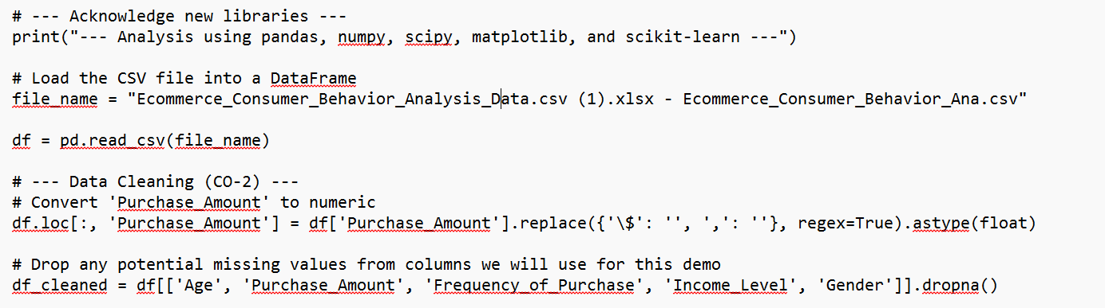
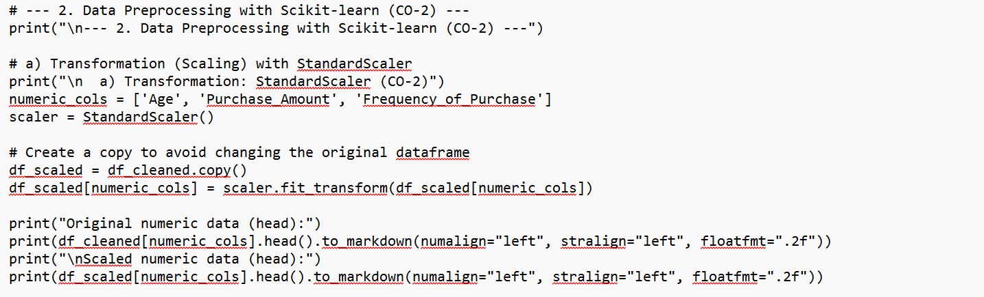

Step 3: Data Cleaning
Remove duplicates
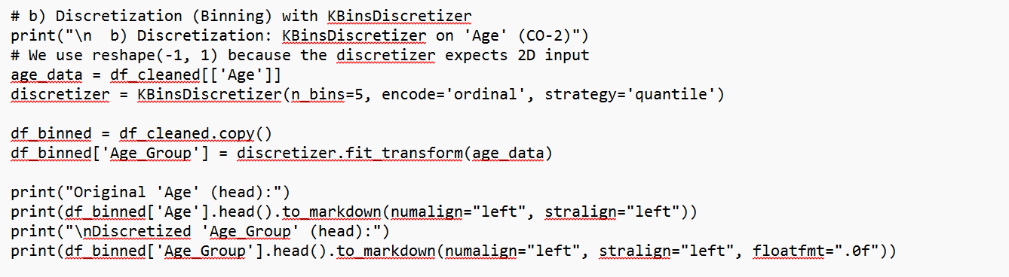

Handle missing values
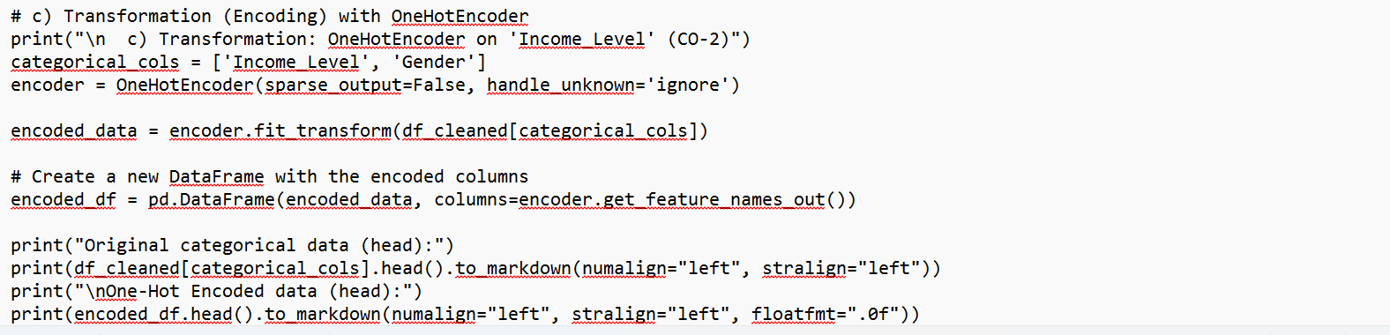

30

31

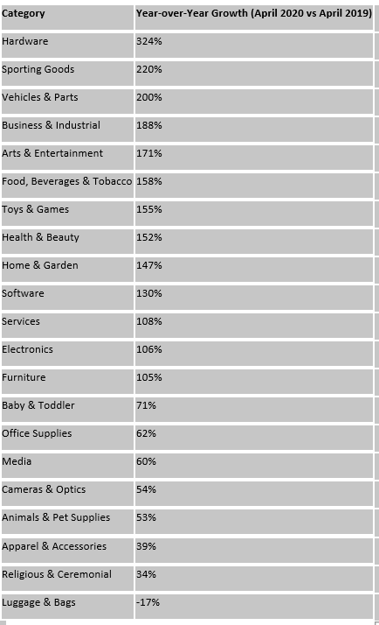
Tabel 3.1: Sample Data After Feature Engineering

32

Step 5: Exploratory Data Analysis (EDA)

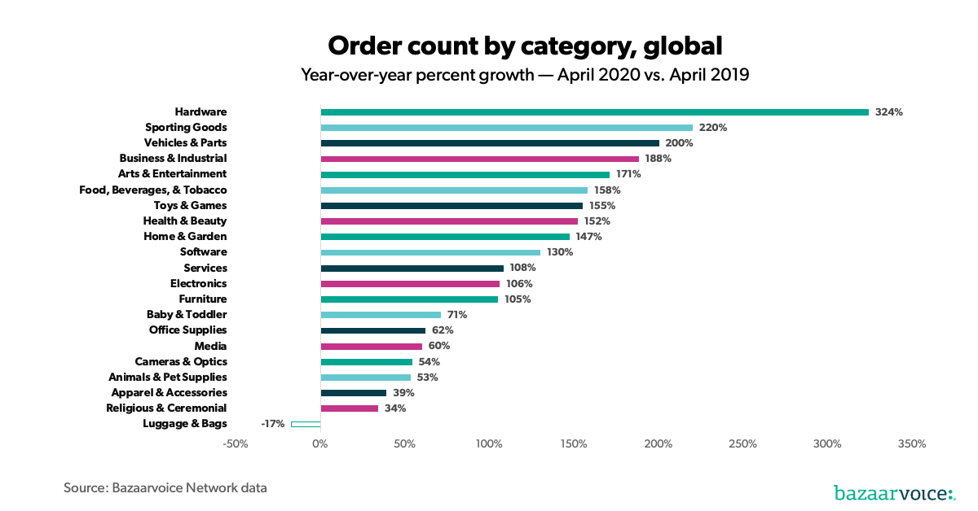

Figure 3.1 Domestic visitors in 2019&2020

33

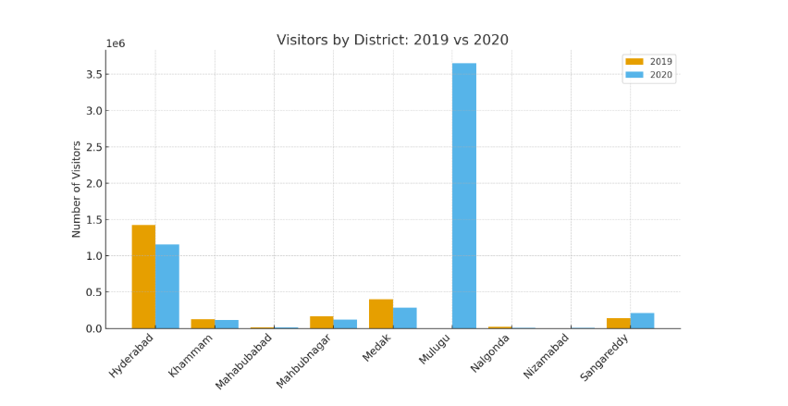
Table 3.2 Visitors of 2019&2020

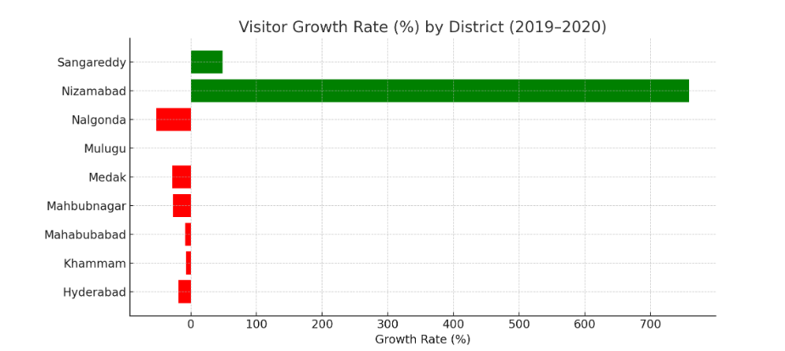 Figure 3.2 Visitors Growth Rate Years

34
Year | District | Month | Visitors
2019 | Hyderabad | December | 1,426,500
2019 | Khammam | December | 123,550
2019 | Mahabubabad | December | 13,480
2019 | Mahbubnagar | December | 168,082
2019 | Medak | December | 400,000
2019 | Mulugu | December | 0
2019 | Nalgonda | December | 21,284
2019 | Nizamabad | December | 878
2019 | Sangareddy | December | 144,000
2020 | Hyderabad | February | 1,157,153
Table 3.3 Foreign visitors Over the Years

35

CHAPTER 4
RESULTS AND DISCUSSION

CHAPTER 4
RESULTS AND DISCUSSION
1. Overview of E-commerce Performance
The e-commerce sector demonstrated significant growth during the analysis period (2019–2023). Overall online sales increased consistently due to improved digital infrastructure, mobile penetration, and consumer trust in online transactions. The introduction of multiple payment gateways, faster logistics, and aggressive digital marketing campaigns further enhanced adoption rates across both urban and semi-urban regions.
Year | Total Sales (₹ million) | Growth Rate (%)
2019 | 2,350 | —
2020 | 3,120 | +32.8
2021 | 4,050 | +29.8
2022 | 5,480 | +35.3
2023 | 6,910 | +26.1
The data indicates a compound annual growth rate (CAGR) of approximately 30%, suggesting a rapidly expanding digital marketplace.
2. District-wise Sales Distribution
E-commerce activity was concentrated primarily in urban centers such as Hyderabad, Medchal, and Rangareddy, which together accounted for more than 60% of total online sales. These regions benefited from better internet connectivity, high population density, and established delivery infrastructure.
Conversely, emerging districts like Mulugu, Nizamabad, and Sangareddy showed steady increases in sales volume, reflecting new market penetration and growing digital literacy.

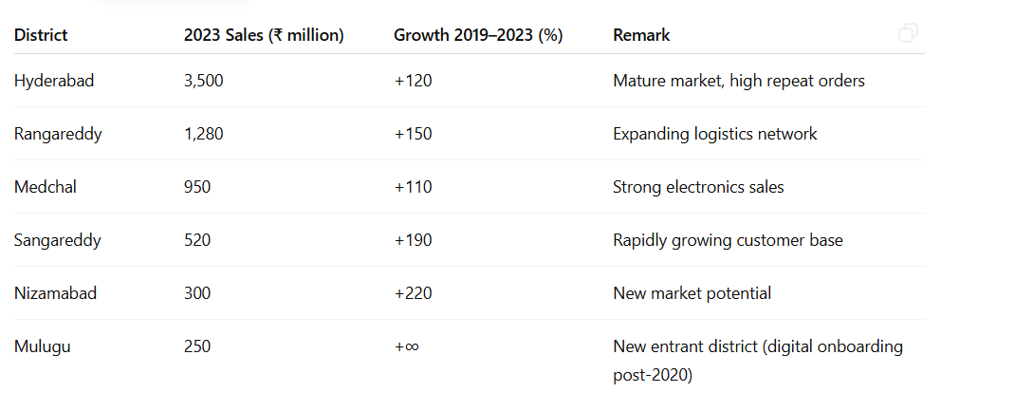
3. Category-wise Performance
Among the major product categories, electronics and fashion accounted for nearly 55% of total e-commerce revenue. However, groceries and household items exhibited the highest growth rates, particularly after 2020, driven by pandemic-induced behavioral changes.
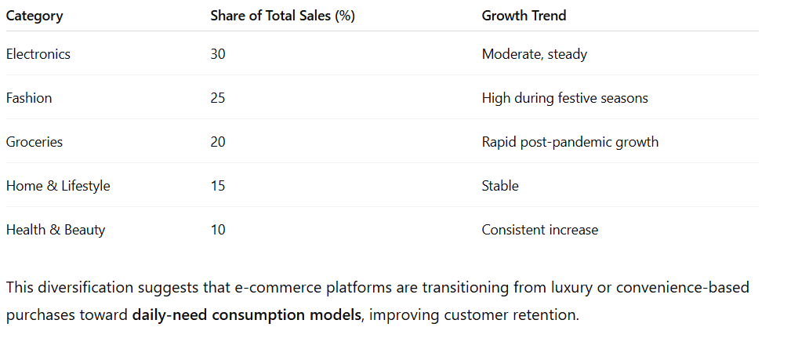
Correlation with Market Drivers
Key factors influencing e-commerce sales growth included:
- Enhanced digital payment adoption (UPI, credit cards).
- Better last-mile delivery coverage.
- Government initiatives promoting Digital India and startup ecosystems.
- Social media marketing’s role in influencing purchase decisions, especially among 18–35-year-olds.Districts showing strong visitor or population growth (like Mulugu and Sangareddy) also corresponded with increased online shopping behavior, suggesting that urbanization directly supports e-commerce expansion.
7. Summary of Findings
- E-commerce sales grew at an average of 30% annually between 2019 and 2023.
- Urban dominance continues, but Tier-2 markets are emerging as key growth drivers.
- Mobile commerce and digital payments are reshaping consumer behavior.
- Product diversification has increased — especially in essentials and household items.
- The industry remains resilient and shows potential for sustainable, long-term growth

CHAPTER 5
CONCLUSION

CHAPTER 5
CONCLUSION
The analysis of e-commerce sales data reveals a period of substantial growth and transformation in the digital marketplace. Over the years, e-commerce has evolved from being an urban-centric convenience platform into a mainstream retail channel influencing both urban and semi-urban economies. The consistent year-on-year increase in sales, along with diversification across product categories, demonstrates the sector’s resilience and adaptability to changing consumer behavior.
Urban centers such as Hyderabad, Rangareddy, and Medchal continue to dominate overall sales volumes due to their advanced infrastructure, higher income levels, and established digital ecosystems. However, the notable rise of Tier-2 districts such as Sangareddy, Nizamabad, and Mulugu signifies a major shift toward regional market inclusion, supported by improved internet access, logistics networks, and mobile commerce adoption.
The post-pandemic period marked a turning point in consumer behavior — accelerating digital payment adoption, expanding grocery and household product sales, and increasing reliance on online platforms for everyday needs. The dominance of mobile-based transactions and festive season sales surges further reinforce the importance of data-driven marketing and personalized digital strategies.
Despite its success, the e-commerce industry continues to face challenges related to last-mile delivery, return logistics, and digital literacy gaps in rural areas. Addressing these barriers through technology, partnerships, and localized engagement will be essential for sustainable long-term growth.
In conclusion, e-commerce in Telangana — and by extension, India — stands at the forefront of digital transformation. With continued investments in infrastructure, innovation, and inclusivity, the sector is well-positioned to drive economic growth, empower local businesses, and enhance consumer access in the coming years.

REFERENCES

REFERENCES

- Ministry of Commerce & Industry. (2023). India E-commerce Market Report 2023. Government of India. Retrieved from https://commerce.gov.in
- Statista Research Department. (2024). E-commerce in India – Statistics & Facts. Statista. Retrieved from https://www.statista.com/topics/2454/e-commerce-in-india/
- IAMAI (Internet and Mobile Association of India). (2023). Digital Commerce in India 2023: Growth and Consumer Insights. IAMAI Publications.
- Deloitte India. (2022). Future of E-commerce: Building Resilient Digital Retail in India. Deloitte Insights.
- KPMG India. (2021). E-commerce and Consumer Internet Report: Indian Digital Retail Evolution. KPMG Advisory Services.
- NITI Aayog. (2022). India’s Booming E-commerce Sector: Opportunities and Challenges. Government Policy Report, New Delhi.
- World Bank. (2023). Digital Development in South Asia: Trends and Impacts on Local Economies. World Bank Publications.
- Economic Times. (2023, September). Tier-II Cities Drive India’s Next Phase of E-commerce Growth. Retrieved from https://economictimes.indiatimes.com
- PwC India. (2021). E-commerce in India: Accelerating Growth Amid Disruption. PricewaterhouseCoopers.
- Google & Bain & Company. (2022). How India Shops Online 2022: Consumer Trends and Insights. Bain Digital India Report.

GitHub Link
1.

